Keynote™ File Filter for OpenOffice.org
Design Hints

Edward Peterlin
7/14/03

Overview

One of OpenOffice.org's goals is to foster the adoption of open standards for document formats to provide freer exchange of information. Similarly, Keynote has an open XML based file format. By providing the ability to import and export Keynote files from OpenOffice.org, OpenOffice.org users will be able to better integrate with a Mac™ environment. Similarly, Keynote users will be able to interact better with alternative platforms.

Objective

The aim of this document is to provide a high-level overview of what is currently known about file filters for the OpenOffice.org Impress presentation component and provide potential directions for implementation of a Keynote filter.

Overview of Existing Filters in OpenOffice.org Impress

OpenOffice.org interacts with documents in alternative file formats through using filters. Filters are usually of two varieties, import and export. Each filter takes a file expressed in a particular format and translates it into internal structures. There are two basic filter types currently implemented in OpenOffice.org Impress (aka “sd”). One of the entry locations for locating these filteres is the sd/source/filter directory in an OpenOffice.org source distribution.

PowerPoint Filters

OpenOffice.org has the ability to interact with files in the Microsoft PowerPoint™ file format. This involvs a pair of filters. The process of opening a PowerPoint document involvs the import filter object:

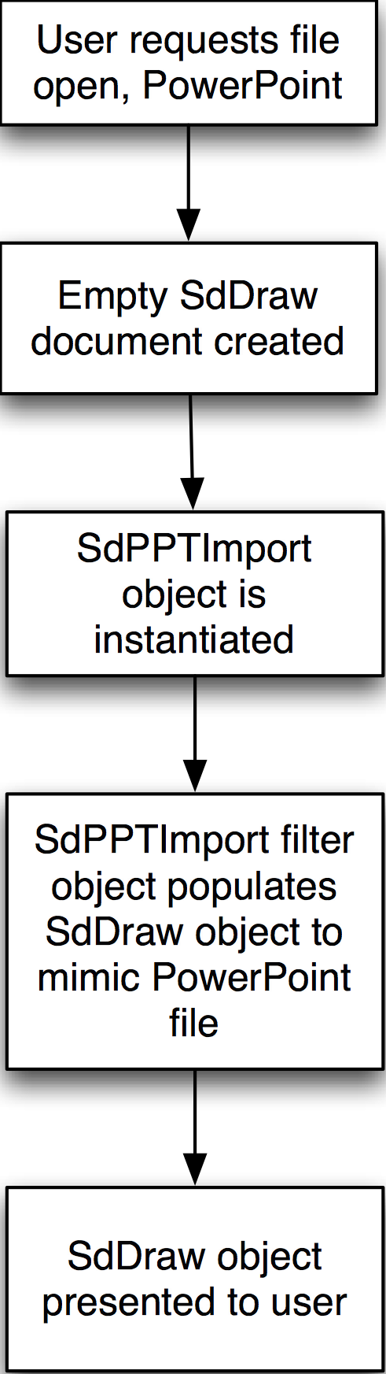
Figure 1: PowerPoint Import into OpenOffice.org

The filter itself is written as C++ code that implements the appropriate translation from a binary stream of PowerPoint formatted data directly into SdDraw objects.

Similarly, there is a PowerPoint export filter implemented in C++. This is an object which parses OpenOffice.org Impress objects and outputs a binary stream corresponding to those objects in binary format:

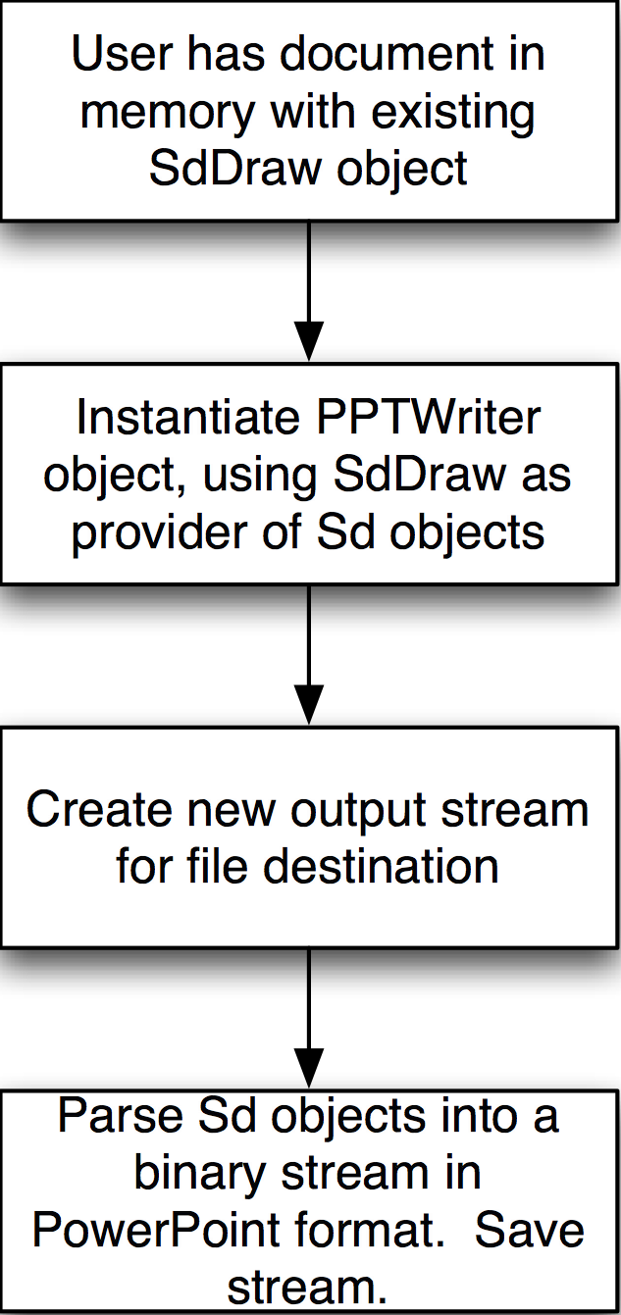
Figure 2: PowerPoint Export from OpenOffice.org

OpenOffice.org XML Format

OpenOffice.org Impress is thus never directly working with PowerPoint data during its presentation or editing, but always data in its own data types and structures.

The native file format of OpenOffice.org is a compressed XML based file format. Each OpenOffice.org file is a ZIP archive containing a number of files. In the case of a draw document, there are separate files for: presentation content, meta information about the document, settings of the program, and different styles (e.g. master slides). Each of these files is handled by a pair of classes, one for import and one for export.

On a high level, however, the Impress code is not directly aware of these classes. It simply sees a single object that can read and write the sd XML format:

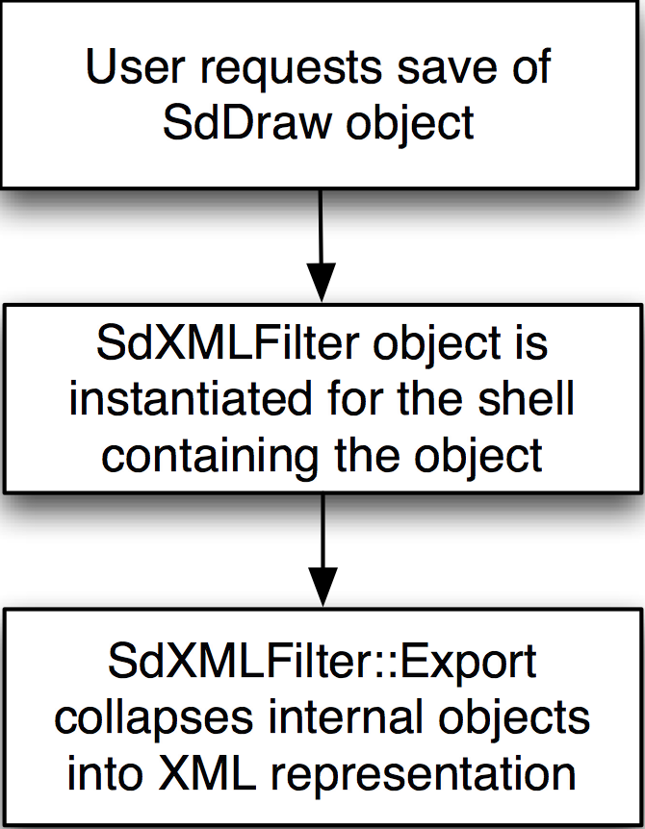
Figure 3: OpenOffice.org XML Save

And conversely, the opening of an OpenOffice.org XML file roughly appears as:

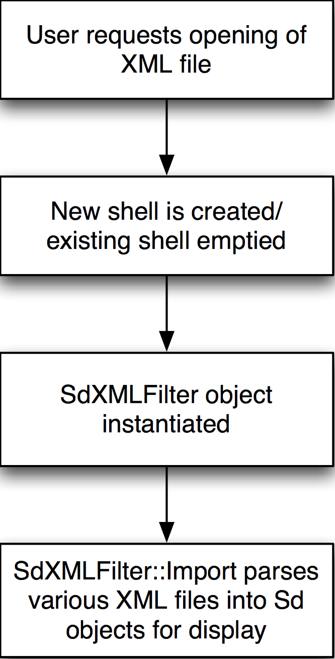
Figure 4: OpenOffice.org XML Open

It appears that all of these filters are wrapped in a generic fashion when presented to sd, at least for user interface purposes. Exploration of how the precise method of overall integration is left for exploration by the implementor...and documentation!

Strategies for Implementing a Keynote Filter

There are multiple possible approaches for implementing a Keynote filter: attempt a binary stream filter similar to the PowerPoint filter, implement a new filter similar in structure to the Sd XML filter, or perform translation and attempt to recycle the existing filter code.

Binary Filter

At first glance, the most immediate parallel for a Keynote filter would appear to be a mirror of the PowerPoint filter. This may not be the best approach. Keynote itself stores its files in an XML format. The PowerPoint filter does not make use of the XML reading and writing code already present within OpenOffice.org, so it may be hard to “learn by example” with the PowerPoint filter for Keynote files.

Raw XML Filter

The idea behind this approach is to roughly create the equivalent of the SdXMLFilter object which, instead of reading and writing the Sd XML format, reads and writes in the Keynote format. The existing structure and tie-in of the SdXMLFilter could be mimiced by the new filter. While this style of filter may provide the tightest integration between the Sd objects and the Keynote format, implementing it will require learning the internal objects of Sd, like master pages and content nodes. Example code for reading and writing these objects should be contained within the various filter classes in the SdXMLFilter.

Recycling SdXMLFilter through XSLT

Because both OpenOffice.org and Keynote use XML based file formats, it may be possible to write an XSLT transform that will mate the two schemas. Both schemas are pubicly documented, so construction of a transform should be possible in theory. Two XSLT transforms would need to be implemented, one to translate from Keynote to OpenOffice.org, and another from OpenOffice.org into Keynote.

Internally, a new 'stub' filter object would be created. For importing, this filter would first invoke the XSLT on a Keynote file to create an OpenOffice.org file, then proceed with the SdXMLFilter::Import() method call on this translated stream. On export, SdXMLFilter::Export() would first be called by the stub export filter to create an OpenOffice.org representation, then the XSLT would be invoked to translate the export into Keynote format.

Implementing this style of filter would not require learning all of the internal object structures of OpenOffice.org, only its file format. It will require some in-depth knowledge of XSLT. Additionally, the implementor will need to investigate whether OpenOffice.org includes an XSLT engine (it is believed that OpenOffice.org 1.0.x does not include an XSLT engine). If no engine is included, the choice should be made to either incorporate one into the source base or to use an external one. Any merging of an XSLT engine with the source base should be designed and peer reviewed by the OpenOffice.org community.

User Interface

The implementation of the Keynote file filter should involve no direct user interface. It will be made accessible as an entry named “Keynote” in the File Type popup menus, similar to the other recognized file types. Once a user selects the “Keynote” filter type, the file dialog should show only files with the appropriate extension and instantiate filters as necessary. The mechanics of determining where this specification occurs must be researched by the implementor.

During import or the Keynote file may be found to contain information that cannot be represented within OpenOffice.org Impress (such as AppleScript invocation commands or certain transitions). In a similar vein to the PowerPoint filters, the Keynote filter will not present any interface elements to the user but simply import as much content as it can from the file. If specific failures are known, the filter may print out to stderr information on any of the skipped elements.

Additional Resources

Keynote Resources

Tech Notes

There are tech notes describing the Keynote XML schema and how to interpret Keynote generated files:

http://developer.apple.com/technotes/tn2002/tn2067.html

http://developer.apple.com/technotes/tn2002/tn2073.html

OpenDarwin

OpenDarwin has a keynote-tools package available for working with keynote files. This may prove to be a helpful project for use in performing the translation:

http://www.opendarwin.org

http://www.opendarwin.org/mailman/listinfo/keynote-tools

OpenOffice.org XML Formats

The OpenOffice.org Impress file format is one of many covered under the general XML file formats of the whole suite:

http://xml.openoffice.org/general.html

http://xml.openoffice.org/xml_specification.pdf
http://xml.openoffice.org/source/browse/xml/xmloff/dtd/

XSLT Tools and References

A useful XSLT tool can be found from the Apache Project if there's no XSLT engine already in Ooo, or a standalone version is needed to play with the transformation separate from the filter itself. Available in Java and C++, and understands Unicode:

http://xml.apache.org/xalan-j/index.html

http://xml.apache.org/xalan-c/index.html

There are some additional resources for learning about XSLT, the process of transforming one XML document into another:

http://www.oreilly.com/catalog/orxmlapp/chapter/ch07.html

http://www-106.ibm.com/developerworks/xml/library/x-extxslt/index.html?open&l=136,t=grx,p=xml

Revision History

7/15/03 [ed] Creation
7/15/03 11:15:11 [ed] Added “References” section.
PUBLIC DOCUMENTATION LICENSE
Version 1.0

1.0 DEFINITIONS.

1.1. "Commercial Use" means distribution or otherwise making the Documentation available to a third party.

1.2. "Contributor" means a person or entity who creates or contributes to the creation of Modifications.

1.3. "Documentation" means the Original Documentation or Modifications or the combination of the Original Documentation and Modifications, in each case including portions thereof.

1.4. "Electronic Distribution Mechanism" means a mechanism generally accepted for the electronic transfer of data.

1.5. "Initial Writer" means the individual or entity identified as the Initial Writer in the notice required by the Appendix.

1.6. "Larger Work" means a work which combines Documentation or portions thereof with documentation or other writings not governed by the terms of this License.

1.7. "License" means this document.

1.8. "Modifications" means any addition to or deletion from the substance or structure of either the Original Documentation or any previous Modifications, such as a translation, abridgment, condensation, or any other form in which the Original Documentation or previous Modifications may be recast, transformed or adapted. A work consisting of editorial revisions, annotations, elaborations, and other modifications which, as a whole represent an original work of authorship, is a Modification. For example, when Documentation is released as a series of documents, a Modification is:

A. Any addition to or deletion from the contents of the Original Documentation or previous Modifications.

B. Any new documentation that contains any part of the Original Documentation or previous Modifications.

1.9. "Original Documentation" means documentation described as Original Documentation in the notice required by the Appendix, and which, at the time of its release under this License is not already Documentation governed by this License.

1.10. "Editable Form" means the preferred form of the Documentation for making Modifications to it. The Documentation can be in an electronic, compressed or archival form, provided the appropriate decompression or de-archiving software is widely available for no charge.

1.11. "You" (or "Your") means an individual or a legal entity exercising rights under, and complying with all of the terms of this License or a future version of this License issued under Section 5.0 ("Versions of the License"). For legal entities, "You" includes any entity which controls, is controlled by, or is under common control with You. For purposes of this definition, "control" means (a) the power, direct or indirect, to cause the direction or management of such entity, whether by contract or otherwise, or (b) ownership of more than fifty percent (50%) of the outstanding shares or beneficial ownership of such entity.

2.0 LICENSE GRANTS.

2.1 Initial Writer Grant.

The Initial Writer hereby grants You a world-wide, royalty-free, non-exclusive license to use, reproduce, prepare Modifications of, compile, publicly perform, publicly display, demonstrate, market, disclose and distribute the Documentation in any form, on any media or via any Electronic Distribution Mechanism or other method now known or later discovered, and to sublicense the foregoing rights to third parties through multiple tiers of sublicensees in accordance with the terms of this License.
The license rights granted in this Section 2.1 ("Initial Writer Grant") are effective on the date Initial Writer first distributes Original Documentation under the terms of this License.

2.2. Contributor Grant.

Each Contributor hereby grants You a world-wide, royalty-free, non-exclusive license to use, reproduce, prepare Modifications of, compile, publicly perform, publicly display, demonstrate, market, disclose and distribute the Documentation in any form, on any media or via any Electronic Distribution Mechanism or other method now known or later discovered, and to sublicense the foregoing rights to third parties through multiple tiers of sublicensees in accordance with the terms of this License.
The license rights granted in this Section 2.2 ("Contributor Grant") are effective on the date Contributor first makes Commercial Use of the Documentation.

3.0 DISTRIBUTION OBLIGATIONS.

3.1. Application of License.

The Modifications which You create or to which You contribute are governed by the terms of this License, including without limitation Section 2.2 ("Contributor Grant"). The Documentation may be distributed only under the terms of this License or a future version of this License released in accordance with Section 5.0 ("Versions of the License"), and You must include a copy of this License with every copy of the Documentation You distribute. You may not offer or impose any terms that alter or restrict the applicable version of this License or the recipients' rights hereunder. However, You may include an additional document offering the additional rights described in Section 3.5 ("Required Notices").

3.2. Availability of Documentation.

Any Modification which You create or to which You contribute must be made available publicly in Editable Form under the terms of this License via a fixed medium or an accepted Electronic Distribution Mechanism.

3.3. Description of Modifications.

All Documentation to which You contribute must identify the changes You made to create that Documentation and the date of any change. You must include a prominent statement that the Modification is derived, directly or indirectly, from Original Documentation provided by the Initial Writer and include the name of the Initial Writer in the Documentation or via an electronic link that describes the origin or ownership of the Documentation. The foregoing change documentation may be created by using an electronic program that automatically tracks changes to the Documentation, and such changes must be available publicly for at least five years following release of the changed Documentation.

3.4. Intellectual Property Matters.

Contributor represents that Contributor believes that Contributor's Modifications are Contributor's original creation(s) and/or Contributor has sufficient rights to grant the rights conveyed by this License.

3.5. Required Notices.

You must duplicate the notice in the Appendix in each file of the Documentation. If it is not possible to put such notice in a particular Documentation file due to its structure, then You must include such notice in a location (such as a relevant directory) where a reader would be likely to look for such a notice, for example, via a hyperlink in each file of the Documentation that takes the reader to a page that describes the origin and ownership of the Documentation. If You created one or more Modification(s) You may add your name as a Contributor to the notice described in the Appendix.
You must also duplicate this License in any Documentation file (or with a hyperlink in each file of the Documentation) where You describe recipients' rights or ownership rights.
You may choose to offer, and to charge a fee for, warranty, support, indemnity or liability obligations to one or more recipients of Documentation. However, You may do so only on Your own behalf, and not on behalf of the Initial Writer or any Contributor. You must make it absolutely clear than any such warranty, support, indemnity or liability obligation is offered by You alone, and You hereby agree to indemnify the Initial Writer and every Contributor for any liability incurred by the Initial Writer or such Contributor as a result of warranty, support, indemnity or liability terms You offer.

3.6. Larger Works.

You may create a Larger Work by combining Documentation with other documents not governed by the terms of this License and distribute the Larger Work as a single product. In such a case, You must make sure the requirements of this License are fulfilled for the Documentation.

4.0 APPLICATION OF THIS LICENSE.

This License applies to Documentation to which the Initial Writer has attached this License and the notice in the Appendix.

5.0 VERSIONS OF THE LICENSE.

5.1. New Versions.

Initial Writer may publish revised and/or new versions of the License from time to time. Each version will be given a distinguishing version number.

5.2. Effect of New Versions.

Once Documentation has been published under a particular version of the License, You may always continue to use it under the terms of that version. You may also choose to use such Documentation under the terms of any subsequent version of the License published by Edward Peterlin. No one other than Edward Peterlin has the right to modify the terms of this License. Filling in the name of the Initial Writer, Original Documentation or Contributor in the notice described in the Appendix shall not be deemed to be Modifications of this License.

6.0 DISCLAIMER OF WARRANTY.

DOCUMENTATION IS PROVIDED UNDER THIS LICENSE ON AN "AS IS'' BASIS, WITHOUT WARRANTY OF ANY KIND, EITHER EXPRESSED OR IMPLIED, INCLUDING, WITHOUT LIMITATION, WARRANTIES THAT THE DOCUMENTATION IS FREE OF DEFECTS, MERCHANTABLE, FIT FOR A PARTICULAR PURPOSE OR NON-INFRINGING. THE ENTIRE RISK AS TO THE QUALITY, ACCURACY, AND PERFORMANCE OF THE DOCUMENTATION IS WITH YOU. SHOULD ANY DOCUMENTATION PROVE DEFECTIVE IN ANY RESPECT, YOU (NOT THE INITIAL WRITER OR ANY OTHER CONTRIBUTOR) ASSUME THE COST OF ANY NECESSARY SERVICING, REPAIR OR CORRECTION. THIS DISCLAIMER OF WARRANTY CONSTITUTES AN ESSENTIAL PART OF THIS LICENSE. NO USE OF ANY DOCUMENTATION IS AUTHORIZED HEREUNDER EXCEPT UNDER THIS DISCLAIMER.

7.0 TERMINATION.

This License and the rights granted hereunder will terminate automatically if You fail to comply with terms herein and fail to cure such breach within 30 days of becoming aware of the breach. All sublicenses to the Documentation which are properly granted shall survive any termination of this License. Provisions which, by their nature, must remain in effect beyond the termination of this License shall survive.

8.0 LIMITATION OF LIABILITY.

UNDER NO CIRCUMSTANCES AND UNDER NO LEGAL THEORY, WHETHER IN TORT (INCLUDING NEGLIGENCE), CONTRACT, OR OTHERWISE, SHALL THE INITIAL WRITER, ANY OTHER CONTRIBUTOR, OR ANY DISTRIBUTOR OF DOCUMENTATION, OR ANY SUPPLIER OF ANY OF SUCH PARTIES, BE LIABLE TO ANY PERSON FOR ANY DIRECT, INDIRECT, SPECIAL, INCIDENTAL, OR CONSEQUENTIAL DAMAGES OF ANY CHARACTER INCLUDING, WITHOUT LIMITATION, DAMAGES FOR LOSS OF GOODWILL, WORK STOPPAGE, COMPUTER FAILURE OR MALFUNCTION, OR ANY AND ALL OTHER DAMAGES OR LOSSES ARISING OUT OF OR RELATING TO THE USE OF THE DOCUMENTATION, EVEN IF SUCH PARTY SHALL HAVE BEEN INFORMED OF THE POSSIBILITY OF SUCH DAMAGES.

9.0 U.S. GOVERNMENT END USERS.

If Documentation is being acquired by or on behalf of the U.S. Government or by a U.S. Government prime contractor or subcontractor (at any tier), then the Government's rights in Documentation will be only as set forth in this Agreement; this is in accordance with 48 CFR 227.7201 through 227.7202-4 (for Department of Defense (DOD) acquisitions) and with 48 CFR 2.101 and 12.212 (for non-DOD acquisitions).

10.0 MISCELLANEOUS.

This License represents the complete agreement concerning the subject matter hereof. If any provision of this License is held to be unenforceable, such provision shall be reformed only to the extent necessary to make it enforceable. This License shall be governed by California law, excluding its conflict-of-law provisions. With respect to disputes or any litigation relating to this License, the losing party is responsible for costs, including without limitation, court costs and reasonable attorneys' fees and expenses. The application of the United Nations Convention on Contracts for the International Sale of Goods is expressly excluded. Any law or regulation which provides that the language of a contract shall be construed against the drafter shall not apply to this License.

Appendix

Public Documentation License Notice

The contents of this Documentation are subject to the Public Documentation License Version 1.0 (the "License"); you may only use this Documentation if you comply with the terms of this License. A copy of the License is available at http://www.openoffice.org/licenses/PDL.rtf.

The Original Documentation is “Keynote File Filter for OpenOffice.org : Design Hints”. The Initial Writer of the Original Documentation is Edward Peterlin Copyright © 2003. All Rights Reserved. (Initial Writer contact(s):http://www.dashboardbuddha.com).

Contributor(s): ______________________________________.
Portions created by ______ are Copyright (C)_________[Insert year(s)]. All Rights Reserved. (Contributor contact(s):________________[Insert hyperlink/alias]).

NOTE: The text of this Appendix may differ slightly from the text of the notices in the files of the Original Documentation. You should use the text of this Appendix rather than the text found in the Original Documentation for Your Modifications.

Keynote™ is a trademark of Apple Computer, Inc. All other trademarks are the property of their respective owners.
Mac™ is a trademark of Apple Computer, Inc.
PowerPoint™ is a trademark of Microsoft, Inc.

